Task 15: Automated Provisioning and Reliability Validation
Step 1 — Verify your project
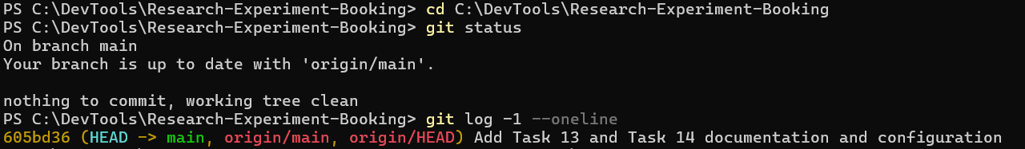
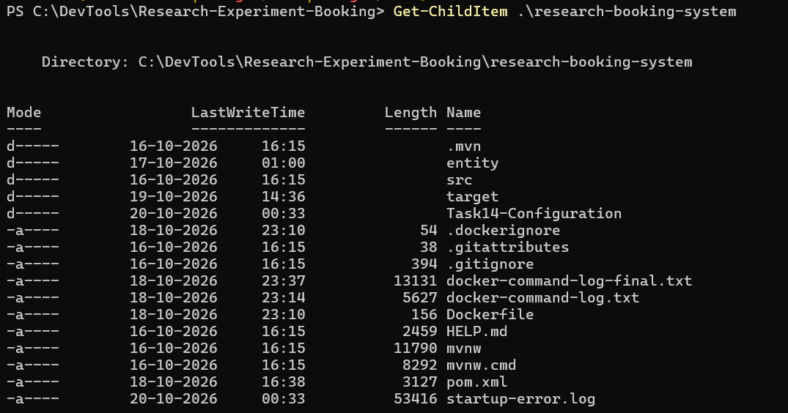
Step 2 — Verify Ansible in Ubuntu
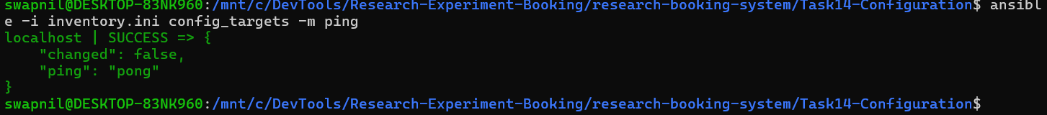
Step 3 — Check whether the application is running
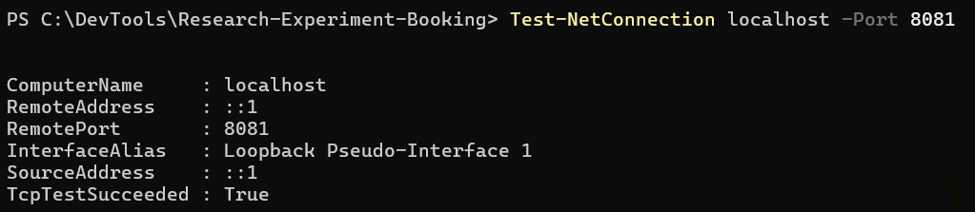
Step 4 — Verify the application health
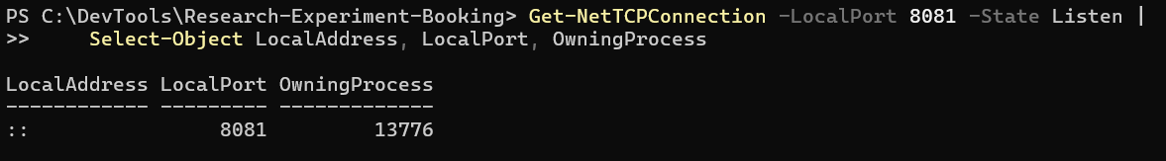
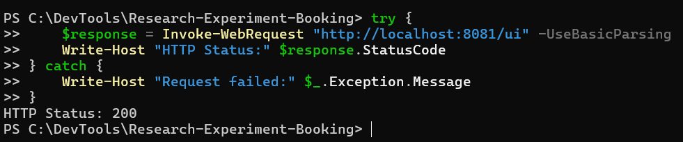
Step 5 — Inspect your existing Ansible configuration
Switch to Ubuntu (WSL)
Display the playbook:
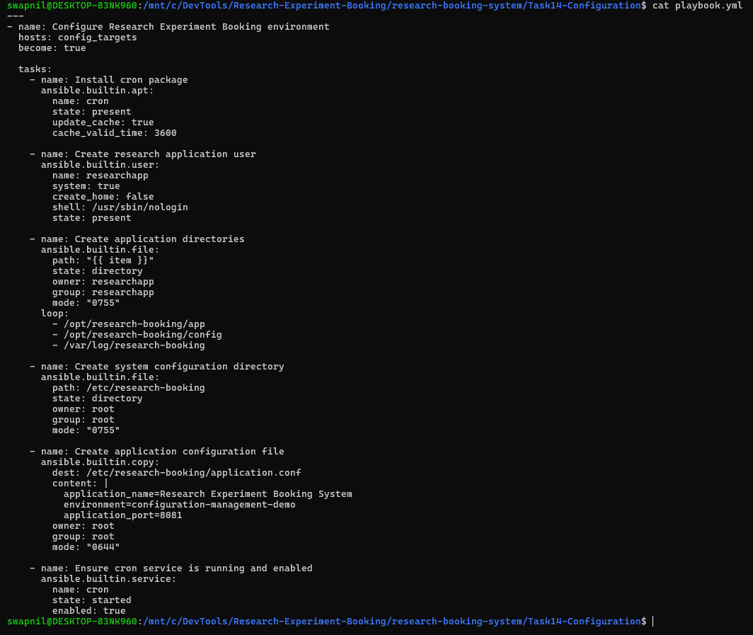
Display the inventory:
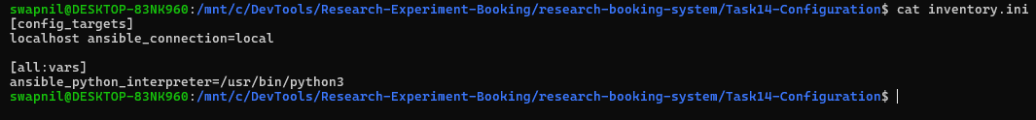
Check your Task 14 deliverables:
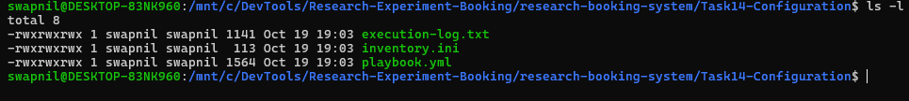
Create a Task 15 evidence folder
Step 2 — Run Ansible for the first time
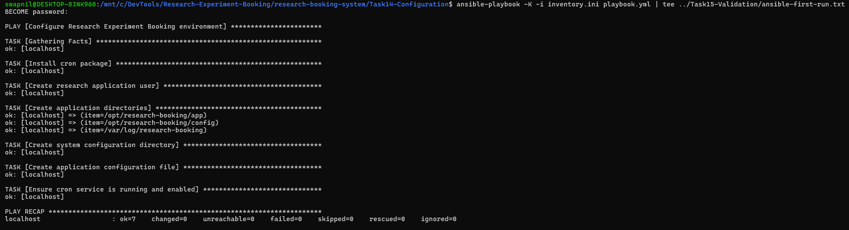
Step 3 — Run Ansible again
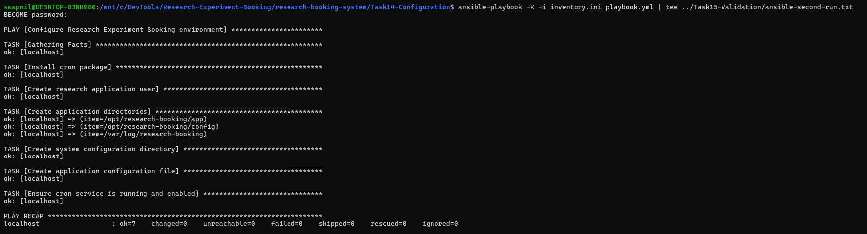
Step 4 — Test application health
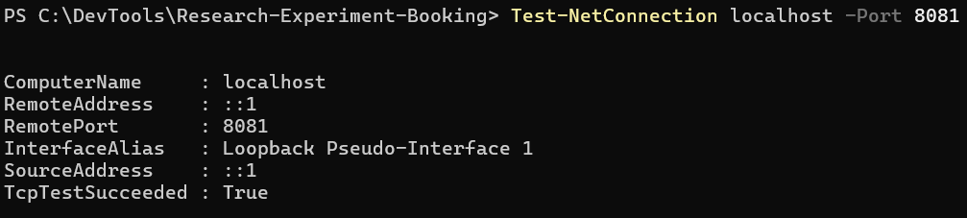
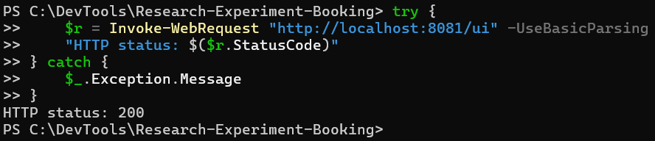
Step 3 — Confirm your saved evidence

